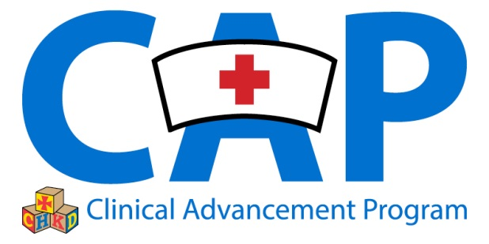

Dear Click here to enter name ,

I am currently applying for clinical advancement through the CAP program at CHKD for which I need two letters of recommendation. Because I value your opinion, I have chosen you to write one on my behalf.

The letter is required to include a timeframe and the capacity of our work relationship. It also needs to address **specific examples** of how my practice is reflective of a minimum of three of the domains of the CHKD nursing model of **Relationship Based Care**: *Leadership, Teamwork, Professional Practice, Care Delivery, Resources and Outcomes.*

I would appreciate it if you could return the letter to me by Click here to enter a date, so that I can include it in my completed portfolio. Thank you for your time and support.

Sincerely,

